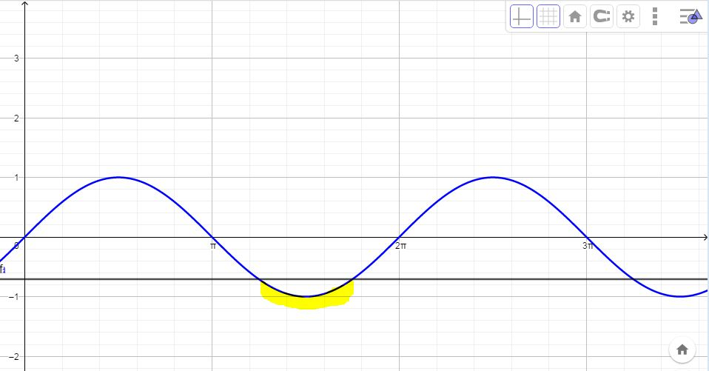
- $\frac{5}{4}π<x<\frac{7}{4}π$

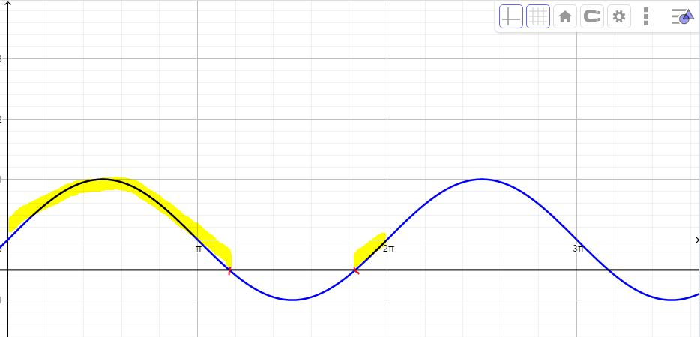
- $0<x<\frac{7}{6}π ∪\frac{11}{6}π<x<2π$

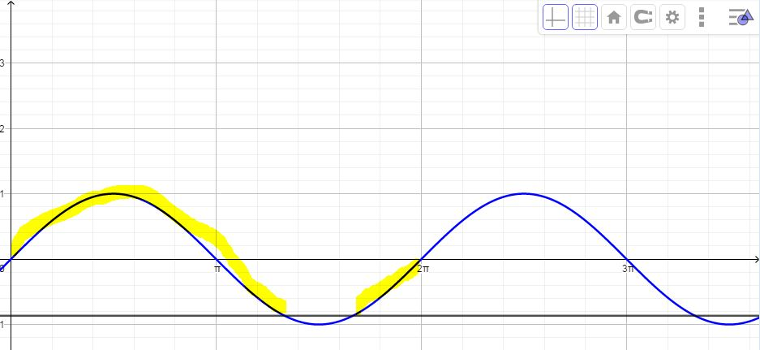
- $0<x<\frac{4}{3}π∪ \frac{5}{3}π<x<2π$

- $0<x<\frac{π}{4} ∪ \frac{3}{4}π<x<2π$


